Contents

IMPORTANT NOTES 3

OVERVIEW 4

REGULATORY INFORMATION 5

SPECIFICATIONS 6

PARTS LIST 6

ETHERNET LAN DESIGN CONSIDERATIONS 7

RS485 LAN DESIGN CONSIDERATIONS 8

ETHERNET LAN NETWORK EXAMPLE 9

FAULT LEDs 9

LAN PROBLEMS 10

INSTALLING THE LAN ETHERNET BRIDGE PCB 10

Module Numbering 11

Factory Default Procedure 12

THE LAN ETHERNET BRIDGE PCB 13

LAN WIRING 14

Lan ethernet bridge powered from external power supply (recommended) 14

Lan ethernet bridge powered from the LAN 15

SYSTEM INPUT MONITORING & REPORTING 16

PROGRAMMING & COMMISSIONING 16

Controller configuration 16

# IMPORTANT NOTES

1) MINIMUM FIRMWARE & SOFTWARE VERSIONS

Integriti/Infiniti ISC/IAC Firmware: V20.1 or later.

LAN Ethernet Bridge Firmware: V1.0.5 or later.

Inception Firmware: V4.0 or later.

Integriti/Infiniti Software: V20.1 or later.

2) SYSTEM ARCHITECTURE

* Legacy Concept LAN Modules supported by the Controller are supported on a LAN Ethernet Bridge.
* A LAN Ethernet Bridge RS485 LAN Port must not be connected to another LAN Ethernet Bridge RS485 LAN Port, or to a Controller RS485 LAN Port.
* The number of LAN Ethernet Bridges associated with a Controller may be limited by a number of factors such as LAN Module types, LAN traffic, Ethernet protocol and Ethernet network QoS. Read “Ethernet LAN Design Considerations” on p3.

3) LEGACY INTELLIGENT 4-DOOR ACCESS MODULE FIRMWARE

When connecting a legacy Concept Intelligent 4-Door/2-Door Access Module (IFDAM / I2DAM) to a LAN Ethernet Bridge, the IFDAM/2DAM Firmware must be V5.0 or later.

4) PROGRAMMING

LAN Ethernet Bridges should be configured prior to installation. Please consult with the IT administrator and provide a copy of this manual prior to configuration programming & installation. Details of the default programming and the configuration options are found starting on page 16.

5) ETHERNET BRIDGE SECURITY

The LAN Ethernet Bridge uses an encryption key/passphrase for ethernet communications security. If using the Default Key, many options on the Ethernet Bridge cannot be changed once it is connected to a Controller. This protects the ethernet connection from being broken by an attacker running the Configuration Tool software on the Ethernet network. If the Bridge cannot connect to the Controller, settings can still be changed. If using a custom encryption key/passphrase, then Bridge settings can be changed, including which Controller it is communicating with. This is possible because the Configuration Tool must also employ the custom key.

6) ETHERNET NETWORK AVAILABILITY

While a dedicated network is best, any network used needs to have high availability and reliability, ideally with more than one path between the Controller and Bridge in the event of an ethernet network fault. Installing a Controller or LAN Ethernet Bridge on the same network as high traffic devices such as CCTV cameras or AV devices is not recommended.

7) POWER SUPPLY A LAN

Ethernet Bridge must be powered from a battery-backed power supply by one of the following methods: • From a nearby RS485 LAN Module within the LAN segment, via the 4-wire LAN connection. • From an Inner Range Smart Power Supply via the 10-way PSU Cable provided with the Power Supply. • From any Inner Range Power Supply V+/V-, LAN+/- or DET+/- via the PSU Cable. P/N: 996794. • From another suitable battery-backed power supply via the PSU Cable P/N: 996794. The power supply DC output must be fully floating.

8) FIRE PROTECTION

This product must be installed into a suitable non-flammable equipment enclosure ensuring that the enclosure has been installed onto a non-flammable surface and away from all flammable materials. Any Conduit entry points that have had the knockout removed but are not used, must also be resealed using Conduit Plugs.

# OVERVIEW

The LAN Ethernet Bridge provides a secure, isolated connection of physically separate RS485 LAN segments over an Ethernet network for Inception, Integriti & Infiniti systems. The electrical isolation achieved between LAN segments also eliminates the potential for earth loops.

The LAN Ethernet Bridge is Installer configurable and employs 128-bit AES encryption for secure Ethernet communications. It enrols on the system as a LAN Module allowing status monitoring and reporting. In Integriti/Infiniti systems it is a type ‘P’ Module. Configuration Tool software is available for programming and commissioning and the firmware is field upgradeable in the same manner as other Integriti RS485 LAN Modules. LED indicators are provided to show system status, faults, Ethernet Port status & data activity and RS485 LAN Data flow.

RS485 cabling remains the preferred method to connect a Module to the Controller. However, to utilize structured cabling systems, or when RS485 cabling is difficult to implement and Ethernet is present, one or more LAN Ethernet Bridges can be installed in remote locations to provide an interface between an Ethernet network and a local RS485 LAN segment. The Ethernet network provides the communication path between the Controller’s on-board Ethernet Port and the LAN Ethernet Bridge. (A Bridge is not required at the Controller) Up to 30 LAN Ethernet Bridges can communicate with a Controller depending on network considerations and up to 30 RS485 LAN Modules can be connected to a LAN Ethernet Bridge RS485 LAN Port.

The Ethernet Bridge may use DHCP IP address allocation or a static (fixed) IP address. Each unit has a unique factory-set MAC address.

# REGULATORY INFORMATION

FCC Statement (North America)

This device complies with Part 15 of the FCC Rules and Innovation, Science and Economic Development Canada’s license-exempt RSS(s). Operation is subject to the following two conditions:

1. This device may not cause interference; and

2. This device must accept any interference, including interference that may cause undesired operation of the device.

**Class B Product:**

This equipment has been tested and found to comply with the limits for a Class B digital device, pursuant to Part 15 of the FCC Rules. These limits are designed to provide reasonable protection against harmful interference in a residential installation. This equipment generates, uses and can radiate radio frequency energy and, if not installed and used in accordance with the instructions, may cause harmful interference to radio communications.

However, there is no guarantee that interference will not occur in a particular installation. If this equipment does cause harmful interference to radio or television reception, which can be determined by turning the equipment off and on, the user is encouraged to try to correct the interference by one or more of the following measures:

* Reorient or relocate the receiving antenna.
* Increase the separation between the equipment and receiver.
* Connect the equipment to an outlet on a circuit different from that to which the receiver is connected.
* Consult the dealer or an experienced radio/TV technician for help. Warning: Any changes or modifications not expressly approved by Inner Range Pty Ltd could void the user’s authority to operate the equipment.

ISED (Canada)

L’émetteur/récepteur exempt de licence contenu dans le présent appareil est conforme aux CNR d’Innovation, Sciences et Développement économique Canada applicables aux appareils radio exempts de licence. L’exploitation est autorisée aux deux conditions suivantes :

1. L’appareil ne doit pas produire de brouillage;

2. L’appareil doit accepter tout brouillage radioélectrique subi, même si le brouillage est susceptible d’en compromettre le fonctionnement.

**CAN ICES-3 (B) / NMB-3(B)**

# SPECIFICATIONS

|  |  |
| --- | --- |
| Supply Voltage | 11 to 14V DC. (LAN or External Power Supply) |
| Current Consumption | 60mA |
| Installation environment | 0º to 49º Celsius (32º to 120º F)  15% to 85% Relative humidity (non-condensing) |
| CABLING  Ethernet Port  RS485 LAN port | As per standard 10/100 Mbps Ethernet cabling specifications. e.g. Cat5e  As per Integriti/Inception LAN cabling specifications. e.g. Shielded, twisted-pair cable. |
| Physical dimensions | **Length:** 105mm / 4.14”  94mm / 3.7” when snap-off mounting strip is removed. **Width:** 94 mm / 3.7”  **Height:** 18mm / 0.71” (Allow 40mm / 1.6” clearance above PCB mounting clips if 10-way Power Supply Cable is connected) |
| Recommended Enclosures | An existing Inner Range tamper-monitored enclosure with one or more other RS485 LAN Modules or a dedicated Inner Range tamper monitored enclosure such as those listed under  ‘Installing the LAN Ethernet Bridge PCB’. |

# PARTS LIST

* LAN Ethernet Bridge PCB assembly.
* Installation Manual P/N: 636088 (this document).

-3 x 2 Way Plug on Screw Terminals.

-1 x PCB to Chassis Earth Cable.

* Installation accessory kit consisting of:

- 4 x M3 x 10mm Pan head screws

- 4 x M3 PCB Mounting Clip

- 4 x Self-adhesive PCB Standoffs

*Note:*

No Ethernet cables are supplied. Standard 10/100 Mbps Ethernet cabling and connections are used.

# ETHERNET LAN DESIGN CONSIDERATIONS

System Design

Recommended method of deployment: Install each Ethernet Bridge in the same enclosure as a LAN Module, or an enclosure immediately adjacent. Connect the Ethernet Bridge’s RS485 LAN Port only to that Module and any other LAN Modules in the same enclosure &/or in enclosures in the immediate vicinity.

Module Address: Although the LAN Ethernet Bridge communicates with the Controller over an ethernet connection, like any other Inner Range LAN Module, a module address must be set for each LAN Ethernet Bridge using the ‘Module Number’ DIPswitches. Ensure that each LAN Ethernet Bridge has a unique address before connecting it to the network.

The Controller and the Ethernet Bridge Modules are not required to be on the same Ethernet LAN. Remote connections, where possible, can be made to Controllers on a different network to the Bridge. Once set up, the Bridge will connect directly via IP to the Controller and provide a virtual RS485 connection to that Controller

Network availability

The network connection between the Controller and LAN Ethernet Bridge appears to the Controller like another RS485 LAN connection. A break or loss of network communication has the same effect as breaking the RS485 cable connection.

If the network connection is interrupted at either end, it will appear as if the Bridge and all the LAN Modules in that segment were disconnected from the Controller. This may result in multiple alarms at once, just as if an RS485 or Fibre Modem cable were broken. i.e. ‘LAN Comms fail’ alarms would be generated for all Modules, etc.

**The network needs to have high availability and reliability. See Important Note 6 on Page 1.**

Basic System Limits

Maximum LAN Modules on a LAN Ethernet Bridge RS485 LAN Port: 30

Maximum LAN Ethernet Bridges per Controller: 30*

Recommended maximum RS485 LAN Modules connected to the Controller via LAN Ethernet Bridges*

LAN data sent & received via LAN Ethernet Bridges requires additional processing for protocol conversion and encryption. This limits how many Modules can reliably communicate with a Controller via ethernet LAN, depending on system configuration & activity. A number of factors must be considered including those listed below along with the peak number of user & automated operations likely to be encountered. The figures below provide a general guide only.

|  |  |  |
| --- | --- | --- |
| SYSTEM COMPOSITION | TCP† | UDP† |
| Intruder Alarm System (No Access Control. No ILAM/IFDAM/I2DAM) | 90 | 120 |
| Access Control or Integrated System with NO ILAM/IFDAM/I2DAM | 60 | 90 |
| Large, busy, Access Control or Integrated System WITH ILAM/IFDAM/I2DAM | 30 | 45 |

*The limit on the number of RS485 LAN Modules (including LAN Ethernet Bridges) per Controller may be further restricted by the following factors:

• Ethernet network QoS. When possible, a dedicated Ethernet network is recommended. If LAN Ethernet Bridges are used on a shared network, consult with the IT administrator on the quality of service that can be made available.

• LAN Module types. Certain Module types such as the ILAM or IFDAM/I2DAM generate constant LAN traffic. Depending on network quality, this may cause delays or Module drop-offs if larger numbers of these are deployed in a system.

• LAN traffic. In addition to the Modules that generate constant LAN traffic, short ‘LAN Poll Time’ settings (<10s) can significantly increase traffic and certain User Terminal operations such as scrolling through Review or information screens can temporarily generate a high volume of traffic.

†Ethernet Protocol. The default protocol is TCP. If network problems are experienced, the UDP option may improve reliability.

NOTE: If the Controller and LAN Ethernet Bridges are not all on the same local network, use of the UDP protocol will require network configuration by the IT administrator.

# RS485 LAN DESIGN CONSIDERATIONS

Connection of the LAN Ethernet Bridge to the Modules on that RS485 LAN segment is in accordance with the normal LAN Module wiring rules and techniques relevant to the particular Controller platform.

It is important that these Modules are not already connected to the Controller via RS485, CLOE or Fibre Modem.

See page 14 and the relevant document/s from the following list for more details:

* Integriti ISC or IAC Controller Installation Manual. (P/N: 636001 or 636035)
* Inception Installation Manual. (P/N: 636300)
* Inception LAN Installation Guide

LAN Termination

As per other products in the Integriti/Inception platform, no LAN Termination is required in the RS485 LAN segments. As such, no Termination Link is provided on a LAN Ethernet Bridge.

# ETHERNET LAN NETWORK EXAMPLE

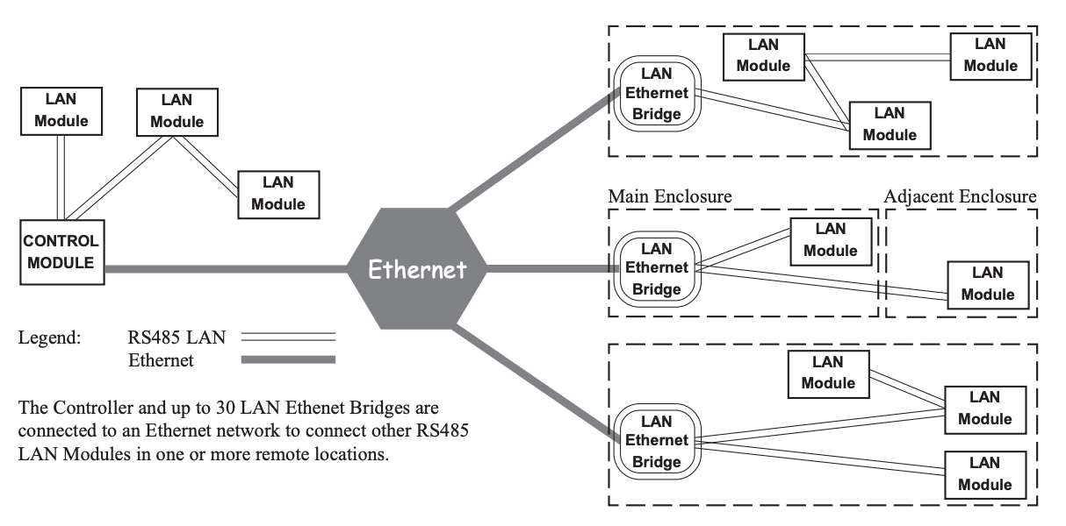

# FAULT LEDs

|  |  |  |
| --- | --- | --- |
| L3 FAULT | | |
| ON | LAN Fault | Refer to “LAN Problems” table below for fault details. |
| FAST Flashing | DIPswitch Reset Pending. | |
| SLOW Flashing | - & L1 Flashing / L2 OFF: | System Fault. Hardware problem.  Return to supplier for repair or replacement. |
| - & L1 OFF / L2 Flashing: | System Fault. Firmware problem.  Return to supplier for repair or replacement. |

# LAN PROBLEMS

If ‘FAULT’ LED (L3) is ON

|  |  |  |  |
| --- | --- | --- | --- |
| L1 | L2 | EXPLANATION / REMEDY | |
| OFF | ON | UNKNOWN. | Module type unknown. Controller firmware upgrade required. |
| ON | OFF | NO ROOM. | Too many Modules on the Network. Check limits and licencing. |
| ON | ON | NO ADDRESS | Module is un-addressed. (Not communicating with the Controller) |
| ON | FLASH | DISABLED. | Module is disabled. |
| FLASH | OFF | CONT/BRIDGE | Another Ethernet Bridge or a Control Module is connected to the RS485 LAN Port.  Check LAN cabling plan. (This condition only monitored in V1.0.6 firmware or later) |
| FLASH | ON | EXISTS. | Duplicate Module. Module number already in use by another LAN Ethernet Bridge. |
| FLASH | FLASH | DIMENSION. | Dimensions. Module number selected is too big.  Select a lower Module number that is not already in use or check limits and licencing. |

# INSTALLING THE LAN ETHERNET BRIDGE PCB

1. It is recommended that the LAN Ethernet Bridges are programmed prior to being installed on the site. See ‘Programming and Commissioning’ for details.
2. The LAN Ethernet Bridge is supplied as a PCB kit and should be mounted in a compatible Inner Range tamper-monitored enclosure using the 4 metal PCB mounting clips and M3 x 10mm screws. e.g.

* An existing enclosure that houses an RS485 LAN Module that the LAN Ethernet Bridge will be connected to.
* A separate tamper protected enclosure such as:

995200PE3. Small, powered enclosure with 3A Smart PS.

995200XS. Extra small, unpowered enclosure.

995200PE2. Small, powered enclosure with 2A Std PS

995200. Small, unpowered enclosure.

or other compatible enclosure that meets system design, power supply & regulatory requirements.

1. The LAN Ethernet Bridge must be powered by a battery-backed power supply. Three power input options are available:

* The LAN+ / 0V terminals on T1 allow the PCB to be powered from the LAN power if available, or from the +/- outputs on a separate power supply. e.g. The LAN+/- outputs on an Inner Range 3A Smart Power Supply.
* The P3 ‘External Power’ input may be used to power the PCB from an Integriti Power Supply via the 10-way PSU bus cable provided with the supply.
* The P3 ‘External Power’ input may also be used to power the PCB from any Inner Range Power Supply, or another compatible battery-backed power supply via the Integriti PSU Cable P/N: 996794.

1. When choosing the location for mounting the PCB in an enclosure, ensure that adequate space is provided for insertion and removal of the Ethernet cable connector.
2. If cabinet tamper monitoring is required, and there is no other RS485 LAN Module in the enclosure, a suitable tamper switch must be fitted in the enclosure, then connected to the ‘Tamper’ input on the LAN Ethernet Bridge.
3. Connect the RS485 LAN according to the instructions on page 14.
4. Connect the Ethernet Bridge Module to the Ethernet LAN via the on-board RJ45 ethernet socket (P2). Note that you may need to delay this step until the LAN Ethernet Bridge has all the required programming and settings entered.

## Module Numbering

The Module number is set using DIPswitches on SW1. DIPSwitches 1 to 5 are used for the LAN Ethernet Bridge. The Module number equals n + 1, where n is the binary number set on the DIPswitches.

|  |  |  |  |  |  |  |  |  |
| --- | --- | --- | --- | --- | --- | --- | --- | --- |
| **Module No:** | **DIPswitch** | **1** | **2** | **3** | **4** | **5** | **6** | **7** |
|  | **Binary value:** | **1** | **2** | **4** | **8** | **16** | **32** | **64** |
| 1 |  | off | off | off | off | off | off | off |
| 2 |  | ON | off | off | off | off | off | off |
| 3 |  | off | ON | off | off | off | off | off |
| 4 |  | ON | ON | off | off | off | off | off |
| 5 |  | off | off | ON | off | off | off | off |
| 6 |  | ON | off | ON | off | off | off | off |
| 7 |  | off | ON | ON | off | off | off | off |
| 8 |  | ON | ON | ON | off | off | off | off |

|  |  |  |  |  |  |  |  |  |
| --- | --- | --- | --- | --- | --- | --- | --- | --- |
| **Module No:** | **DIPswitch** | **1** | **2** | **3** | **4** | **5** | **6** | **7** |
|  | **Binary value:** | **1** | **2** | **4** | **8** | **16** | **32** | **64** |
| 9 |  | off | off | off | ON | off | off | off |
| 10 |  | ON | off | off | ON | off | off | off |
| 11 |  | off | ON | off | ON | off | off | off |
| 12 |  | ON | ON | off | ON | off | off | off |
| 13 |  | off | off | ON | ON | off | off | off |
| 14 |  | ON | off | ON | ON | off | off | off |
| 15 |  | off | ON | ON | ON | off | off | off |
| 16 |  | ON | ON | ON | ON | off | off | off |
| through to |  |  |  |  |  |  |  |  |
| 31 |  | off | ON | ON | ON | ON | off | off |

## Factory Default Procedure

1) Disconnect power from the PCB.

2) Note the DIPswitch address setting, then set the DIPswitches to the required default option. See below.

3) Reconnect power to the PCB and wait 5 seconds.

4) Disconnect power from the PCB.

5) Set the DIPswitches back to the Module address number.

6) Reconnect power to the PCB.

DIPswitch 1 to 7 ON

Reset settings to factory default except for Encryption Key.

All DIPswitches ON.

Reset all settings to factory defaults.

# THE LAN ETHERNET BRIDGE PCB

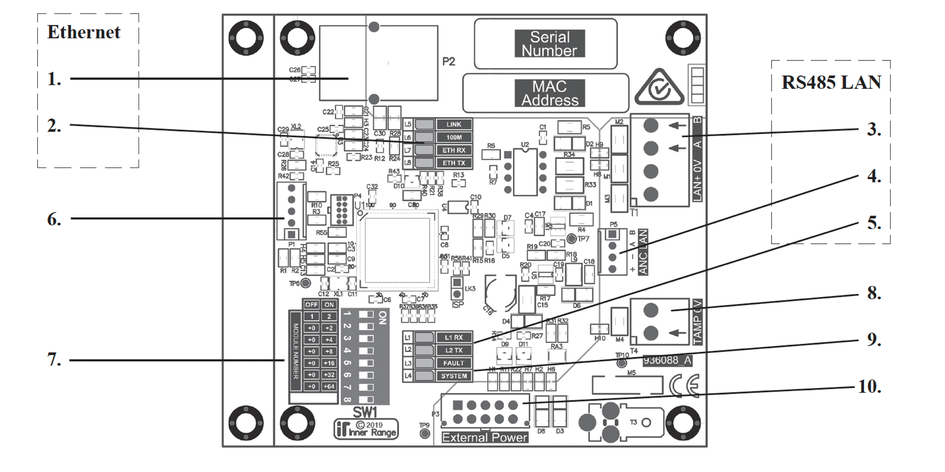

ETHERNET PORT

**1. P2.** Ethernet Port

**2. Ethernet Status LEDs**

**L5.** **LINK** On Ethernet connection present.

Flash Ethernet network activity.

**L6.** **100M** Off 10Mbps Ethernet speed.

On 100Mbps Ethernet speed.

**L7/L8.** **ETH RX/ETH TX**

Flickering. Indicates Ethernet traffic

RS485 LAN PORT

**3. T1.** LAN+, 0V, A, B. RS485 LAN Connection.

Twisted Pair Cable must be used for LAN A & LAN B.

**4. P5.ANC LAN** Ancillary LAN Connection.

For temporary connection of an LCD/EliteX

Terminal when required via the “Ancillary LAN

Cable”, P/N 993028.

**5. L1 RX.** Receiving data on the RS485 LAN.

**L2 TX.** Sending data on the RS485 LAN.

NOTE:

If the ‘FAULT’ LED is ON or Flashing, L1 & L2 are used to indicate the type of problem. See table on page 10.

GENERAL

**6. P1. Port 0.** Temporary configuration connection. For programming and commissioning via “Port 0 Cable” (P/N:993030 / 993030USB).

**7. SW1. DIPswitch**

1 to 5 Sets the RS485 LAN Address.

1 to 7 ON Reset settings to factory default except for Encryption Key. See page 11.

All ON. Reset all settings to factorydefaults. See page 11.

**8. T4. TAMP/0V**. Cabinet Tamper Input.

**9. Status LEDs**

**L3. FAULT**:

See table on page 10.

**L4. SYSTEM.**

Slow Flash. Device running OK

Fast Flash Internal Fault. Return for service.

**10. P3. External Power.**

External Power Supply Input via Smart PSU

Bus Cable.

# LAN WIRING

## Lan ethernet bridge powered from external power supply (recommended)

The LAN is connected using twisted pair cable. e.g. RS485 / RS422 data cable or Category 5 cable. One pair is used for Data A & B, and the other pair is used for POS & NEG.

* If the Module has a local Power Supply connected, the LAN+ terminal may be used to provide power to LCD Terminals, etc. in the vicinity of the module. However, if used in this way, note that this terminal must not be connected to the POS terminal on other LAN Modules, Controller, Power Supplies or any other Module where LAN+ is also a power source.
* If required, the LAN to subsequent Modules may derive +12V from the incoming LAN cable. *See diagram.
* Current drawn from LAN POS and DET+ must not exceed the limit of the Power Supply source.

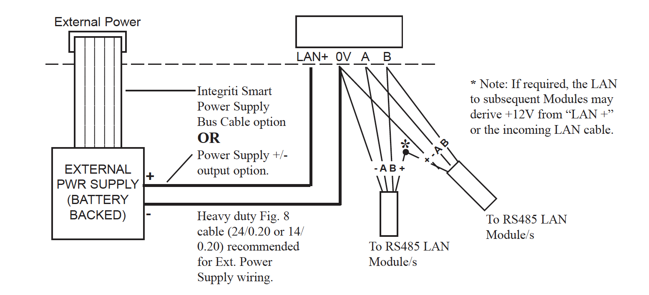

## Lan ethernet bridge powered from the LAN

NOTES:

* * If both “LAN +” wires provide a Power supply source, the one that is not required to power the Module must not be connected.
* Ensure that adequate power supply current and backup battery capacity are available from the power supply source when powering the Module from LAN+.

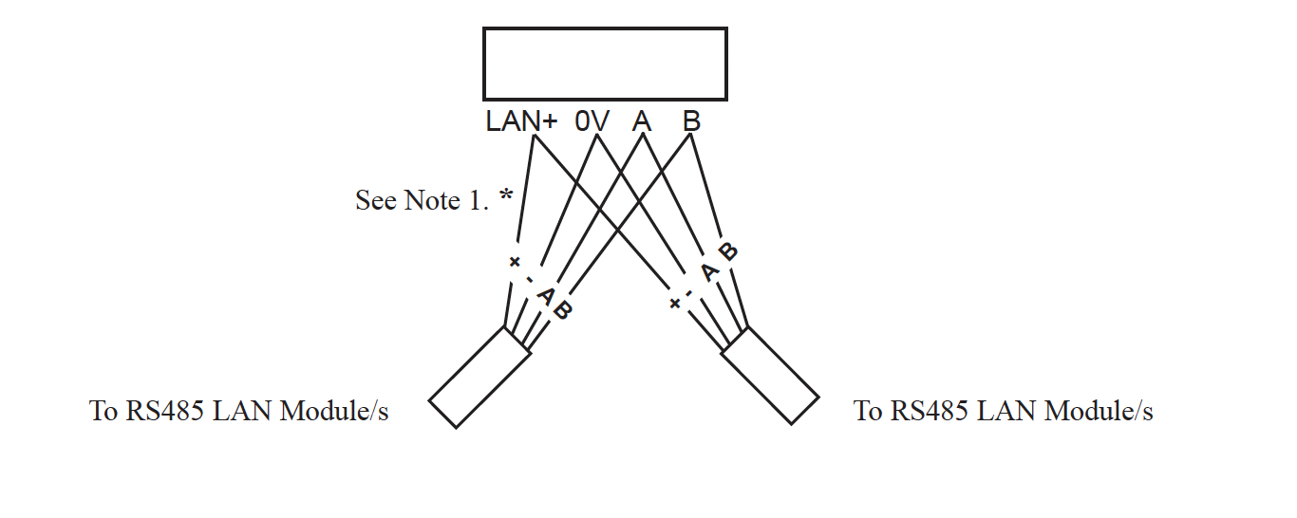

# SYSTEM INPUT MONITORING & REPORTING

In Integriti/Infiniti systems, the LAN Ethernet Bridge uses 10 of the 16 System Inputs allocated to the Module type as follows:

Pnn:S01 Cabinet Tamper. Pnn:S06 LAN Fuse. Pnn:S14 PS Fail.

Pnn:S02 AC Fail. Pnn:S09 RS-485 LAN Comms Fault * Pnn:S15 Battery Test Fail.

Pnn:S03 Low Battery. Pnn:S13 Low Volts. Pnn:S16 LAN Comms Fail.

Pnn:S05 Detector Fuse.

* Pnn:S09 alarm means that a Control Module or another LAN Ethernet Bridge or connected to the RS485 LAN Port (T1).

# PROGRAMMING & COMMISSIONING

## Controller configuration

The Ethernet LAN encryption key needs to be set in the Controller. Once the key is changed, all online Ethernet Bridges on that Controller will automatically update to the new key. The key must be 32 Hexadecimal characters (16 bytes). If the key is set to all zeros, this is treated as default encryption.

A Controller supplied with, or upgraded to, the minimum required firmware version (see Important Note 1 on page 1) will have the default key of all zeros, represented by a blank encryption key/passphrase programming field.

Upon upgrade, Ethernet Bridges with a custom key will not connect until the Controller is programmed with a matching key. Until then, the Bridges and all attached Modules will appear offline.

Integriti/Infiniti

The Software or an LCD/EliteX Terminal may be used. Setting encryption key in the software:

1) Edit the Controller and select the “Module Details” tab.

2) Expand the “Ethernet LAN Options”.

3) The key can be entered as a hex string or as a passphrase. Click on the ellipsis (...) symbol to open the encryption key entry dialog.

* Hex. Key: Select ‘Hex bytes (32 characters)’, then enter the key in the field “Set Encryption Key to:’. The key must be 32 hexadecimal characters.
* Passphrase: Select ‘Passphrase (text)’, then enter the key in the field “Set Encryption Key to:’. The passphrase can be entered as alpha-numeric text.

4) Click on “OK” to close the dialog.

5) Click on “Save”.

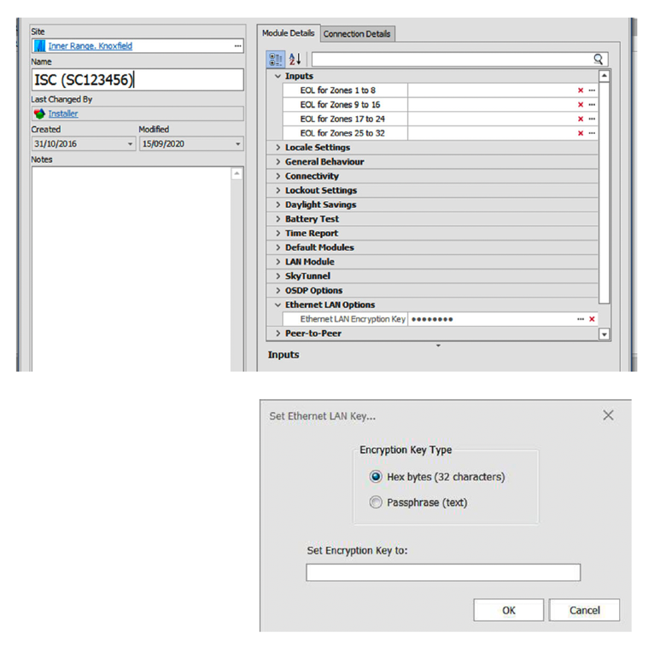

Setting encryption at an Elite/EliteX LCD Terminal: (Prisma/PrismaX not supported)

1) Log on to the Terminal and press MENU, 7, 5, 1

2) As the key is 32 characters long, it is entered over 2 screens; “Eth. LAN Key” and “Eth Key (cont)”, for entering each of the 1st 16 and last 16 characters.

Scroll to the “Eth. LAN Key” screen. As this is a new option, this is most easily accessed by scrolling backwards with the Left Arrow key.

3) Enter the 1st 16 characters, then press the OK key.

4) The “Eth Key (cont)” screen will now be displayed. Enter the remaining 16 characters, then press OK to save the key.

5) Press END to exit the menu.

Inception

1) Ethernet LAN encryption can be set in the Inception Browser from the [Configuration > General > System Settings] page.

2) Select the LAN Encryption type you wish to use. ‘Key’ or ‘Passphrase’.

3) Enter the key or passphrase data in the field ‘LAN Encryption Key/Passphrase’. If a key, it must be 32 hexadecimal characters.

4) Click on “Save”.

After the encryption key is set

If the encryption key is changed in a system that already has LAN Ethernet Bridges communicating with the Controller, then when the new encryption key is saved, any attached Bridges and their LAN Modules will briefly go offline and come back online, using this new key. i.e. Bridges that are currently connected should use the new key automatically.

If you are using the LAN ethernet Configuration Tool, these Bridges will display as using a different encryption key. To use the Configuration Tool software to change LAN Ethernet Bridge settings after a custom key has been programmed or changed, the custom key must also be entered in the Configuration Tool.

Make “Set App Custom Key” to be the same as the controller key, and the Bridges will appear again highlighted in green or yellow.

If a Bridge is offline when an encryption key change is made, it may still be stuck using the old key. In this case you will need to update the Bridge using the Configuration Tool or the Port 0 Console.

If using the Configuration Tool:

1) Set the tool to use the old key.

2) Select the Bridge and set it to use the new custom key.

3) Then set the tool to use the new custom key also.

If the Controller is ever defaulted it will revert to using the default key. If you reconnect a defaulted Controller back to the Software, the server will reprogram the custom key when the Controller is synced to the Software.

Do not connect the Controller to Software that is earlier than V20.1 as the old software may overwrite the key in the Controller.

LAN ETHERNET BRIDGE CONFIGURATION

Each LAN Ethernet Bridge should be configured prior to being connected to the Controller. As a minimum, the Controller IP Address and Ethernet LAN Encryption Key should be set. This is easily performed using the LAN Ethernet Bridge Configuration Tool Software.

NOTE: Settings can be reset to the factory defaults using the DIPswitches. See details on page 11 & 6.

The Configuration Tool Software can be downloaded from the Inner Range Website ‘Technician Downloads’ portal. (Login is required) Select; Integriti > LAN Management Products > LAN Ethernet Bridge, then choose ‘Utilities, Tools & Drivers’.

Configuration Tool Software Notes:

• The Inner Range Ethernet LAN Configuration Tool must be on the same local network as any Bridge that it is trying to configure.

• When the Controller is not on the same LAN as the Configuration Tool, its URL must be entered manually, as the Controller will not be discovered automatically.

• To change settings once a Bridge is connected to a Controller, there are three options:

- Unplug the Controller’s ethernet connection. i.e. Break the connection between the Controller and the Ethernet Bridge, while still allowing the Bridge to talk to the Configuration Tool.

- Change the encryption key via LCD Terminal so that the encryption key in the Controller, Bridge and Configuration Tool all match.

- Use the LAN Ethernet Bridge Port-0 interface to connect locally.

Install the Configuration Tool software on a PC that can be connected to the same network as the LAN Ethernet Bridge.

Open the Inner Range Ethernet LAN Configuration Tool software. It should show all the Ethernet Bridges on your Ethernet LAN network. See example image below.

Each LAN Ethernet Bridge is uniquely identified by it’s Module Number (DIPswitch address), MAC Address & Serial Number. This is to assist in identifying the Ethernet Bridge you wish to configure.

Normally, a new Ethernet Bridge should be in the “Not Connected” state, and the “Assigned Controller” field should be blank.

If any bridges have not appeared in the list, select ‘Refresh Module List’.

On a Network Running DHCP

To assign one or more Bridges to a Controller, multi-select the Bridges to be configured to a single controller and then select “Assign Selected Modules to Controller”. If your Controller has an IP address on the same network as your PC, it should appear in the list in the drop-down box (as pictured)

Select the Controller and press OK.

The Bridge/s will be assigned to the Controller automatically and the Configuration Tool will report success when done.

To assign a static IP to a Bridge

Obtain the required IP Addresses and other necessary details from the Network System Administrator.

Select “Set Module’s IP Address”.

Check “Static IP” bubble, configure as required and select OK:

The Configuration Tool will report success when done.

Each Bridge and all it’s hosted Modules should appear on the Controller’s list of Modules in the

System Software/Browser. All LAN Modules associated with each Bridge should work as if they were connected via the normal RS485 LAN.

*NOTE*: It is also possible to auto-configure LAN Ethernet Bridges with theController’s address, using DHCP option 125 or a DNS SRV record. This may be useful for larger-scale deployments if the necessary IT resources are available. Contact Inner Range Technical Support for details.

Testing & Troubleshooting

1) Check the Ethernet Bridge status LEDs.

“SYSTEM” should flash slowly.,

“FAULT” should be off.

When P2 is connected to a switch/router/ hub:

“LINK” is On or flickering. “ETH TX/ RX” are flickering.

When T1 is connected to the Concept RS485 LAN: “RX” & “TX” flash occasionally

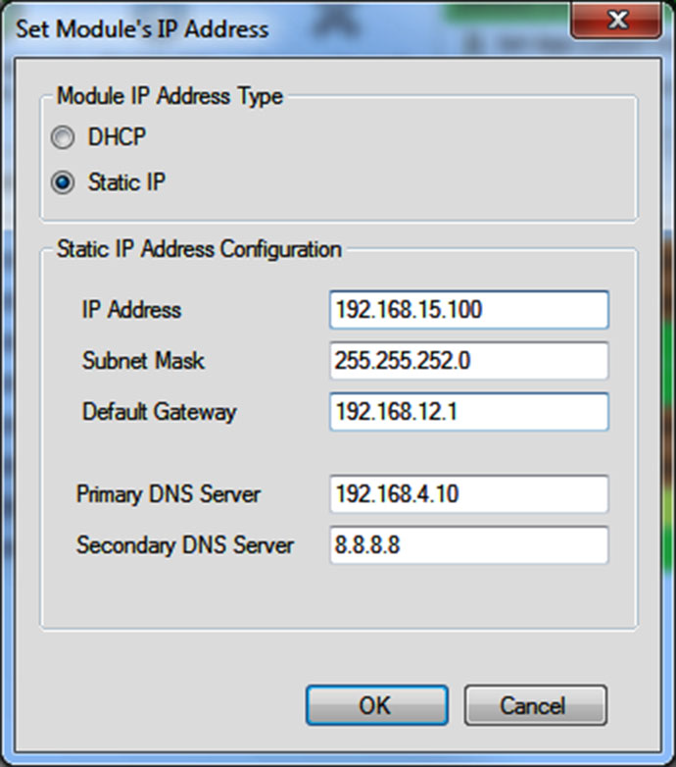

2) To help protect against Module substitution, performing a “LAN Secure” operation is recommended.

a) If an Integriti or Infiniti system, this can be done:

* From the System Software by right-clicking on the Controller in the Navigation Pane, then
* ‘LAN’ > ‘Secure System’.
* From an LCD Terminal, MENU, 7, 8, 1.

b) If an Inception system, when new Modules are added, a new warning will be shown indicating the LAN is not secured. View the warnings and select ‘Send LAN Secure’.

‘Send LAN Secure’ can also be performed from the [State / Control > Hardware Test] page

3) Check that all expected Modules are present.

a) If a ‘LAN Secure’ was performed, check the Review/Event Log. Events will be logged for all Modules that are installed in the system and are currently operational.

* Integriti/Infiniti will show a “Module Found” message for each Module.
* Inception will show a “Connected” message for each Module. Note that the ‘Hardware’ category must be enabled.

4) The status of individual Modules can also be checked.

a) Integriti/Infiniti:

* From an LCD Terminal, logon as Installer and press MENU, 1, 8, OK, then use the DOWN Arrow to scroll through the Modules. The current status of the Module is displayed.
* From the Software using the ‘Navigation’ window &/or the ‘Hardware’ Menu.

b) Inception:

* From the Browser, [State/Control > View Hardware] (Note: The Modules must be Configured to be shown)

System Programming

Unless a shorter setting is required by local regulations or other factors, the default ‘LAN Poll Time’ setting of 1 minute is recommended for all Modules.

The Controller ‘LAN Fail Delay’ or ‘Module Failed Time’ setting should also be left at the default setting, but could be increased a little if necessary to limit brief comms interuptions causing Module off-line alarms. If changed, choose a setting which maintains compliance with relevant regulations.

The LAN Ethernet Bridge supports a Cabinet Tamper input plus normal Module System Inputs for LAN comms and Smart Power Supply. No Zone Inputs or Auxiliaries are supported.

For an Integriti or Infiniti system, program the System Inputs for monitoring and reporting as required. As the LAN Ethernet Bridge is a critical communications path to LAN Modules, monitoring and reporting of the System Inputs should be given a high priority, particularly the “LAN Comms” alarm.

For an Inception system, in the Hardware Configuration, ensure that the required tamper and system health monitoring options are enabled for LAN Ethernet Bridges and their associated RS485 LAN Modules. e.g. Cabinet Tamper Switch Type, SMART Power Supply & Battery options, etc.

Installer Serial Console

The LAN Ethernet Bridge has an Installer Console for configuration of each board if required.

This is accessed through a Terminal program on a Computer or Laptop, which is temporarily connected using a Port 0 cable to connector P1 (Port ‘0’) on the LAN Ethernet Bridge board.

Port 0 USB Cable: P/N 993030USB

Port 0 RS-232 Cable: P/N: 993030

This connection can be used to view &/or edit the settings of a LAN Ethernet Bridge or to reset it to the factory default settings. Serial port settings required are 8, N, 1 and 115200 baud.

e.g. Once connected, typing:

- “default all” will reset the Bridge to the factory defaults.

- “controller [ip] [tcp|udp]” allows you to connect to a controller at the specified IP protocol.

- “status” shows network and connection info

- “info” gives info about the Bridge itself.

- “?” displays a list of commands.

See examples below. Contact Inner Range Technical Support for more details.

Serial Console command examples

Info command returns general details about the Ethernet Bridge.

>>> info

IR LAN Ethernet Bridge

serial-number. EB000017

mac-address 00:11:B9:FF:01:28

board-revision A

app-version 1.0.2.38443

bootloader-version 0.9.5.38835

module-number 1

reset-reasons power

uptime 0 day 0 hr 25 min

Status command returns network and connection information.

>>> status

ethernet

link up

ip

config dhcp

address 192.168.1.129

netmask 255.255.252.0

gateway 192.168.1.1

domain example.com.au.

dns1 192.168.1.10

controller

name 192.168.1.31

transport udp

port 5381

connection

comms-state udp-running

bridge-connected yes

modules-connected 3

modules-unconnected 0

power

smart-ps installed

smart-ps-faults low-batt

power-faults none

faults

none

Help or ? command returns the list of commands and parameters.

>>> help

help

controller [<controller-address>

[tcp|udp] [<port>]]

default

dnslookup <address> [<rr-type>]

info

ip

ip dhcp

ip static [address] [netmask]

[gateway]

lan stats [reset]

ping <address>

rs485 stats [reset]

security

security default

security key <32-hex-digits>

security passphrase <passphrase>

status

**Disclaimer:**

While every effort has been made to ensure the accuracy of this manual, the manufacturer assumes no responsibility or liability for any errors or omissions. Due to ongoing development, this manual is subject to change without notice.

**Designed & manufactured in Australia.**

May 2025

The specifications and descriptions of products and services contained in this document were correct at the time of publishing.

Inner Range reserves the right to change specifications or withdraw products without notice.

Copyright ©2025 Inner Range Pty. Ltd., Australia